### Demographics survey

**1. Your age** _____________

**2. Your email address** _____________

**3. What is your current gender identity?**

Woman

Man

Trans Male/Trans Man

Trans Female/Trans Woman

Genderqueer/Gender non-conforming

Different Identity

Prefer not to say

**4. What sex were you assigned at birth, meaning on your original birth certificate?**

Male

Female

**5. What is your current weight and height? Please estimate to the best of your abilities.**

Weight: __________________ kg

Height: __________________ cm

**6. How would you describe your main racial/ethnic background?**

Australian – neither Aboriginal nor Torres Strait Islander

Australian Aboriginal or Torres Strait Islander

Pacific Islander, or other Oceania

British or European

Asian

Middle Eastern

African

North American

Central or Southern American

**7. Please indicate the highest level of education you have completed.**

(1) Still at secondary school (2) Did not finish secondary school

(3) Year 12 or equivalent (4) Certificate level, diploma, or advanced diploma (5) Bachelor's degree

(6) Postgraduate Degree (e.g. Honours, Masters, Doctorate, PhD)

**8. Are you currently employed? (paid / volunteer / unpaid)**

(1) Yes (2) No

If yes, how many hours do you work per week? __________________

**9. How many hours do you exercise per week (taking your free time to exercise?).**

**10. What kind of exercise do you do? / do you have gym access?**

**11. How many hours do you listen to music per week (estimate)?**

**12. How do you usually listen to music? (e.g. if listening to music in your phone, indicate the name of the app)**

### Depression Anxiety and Stress Scales - DASS Y

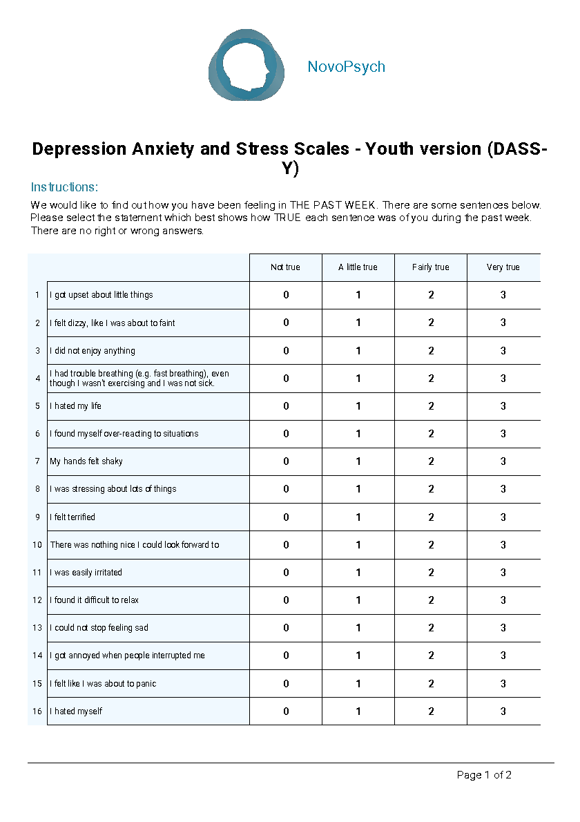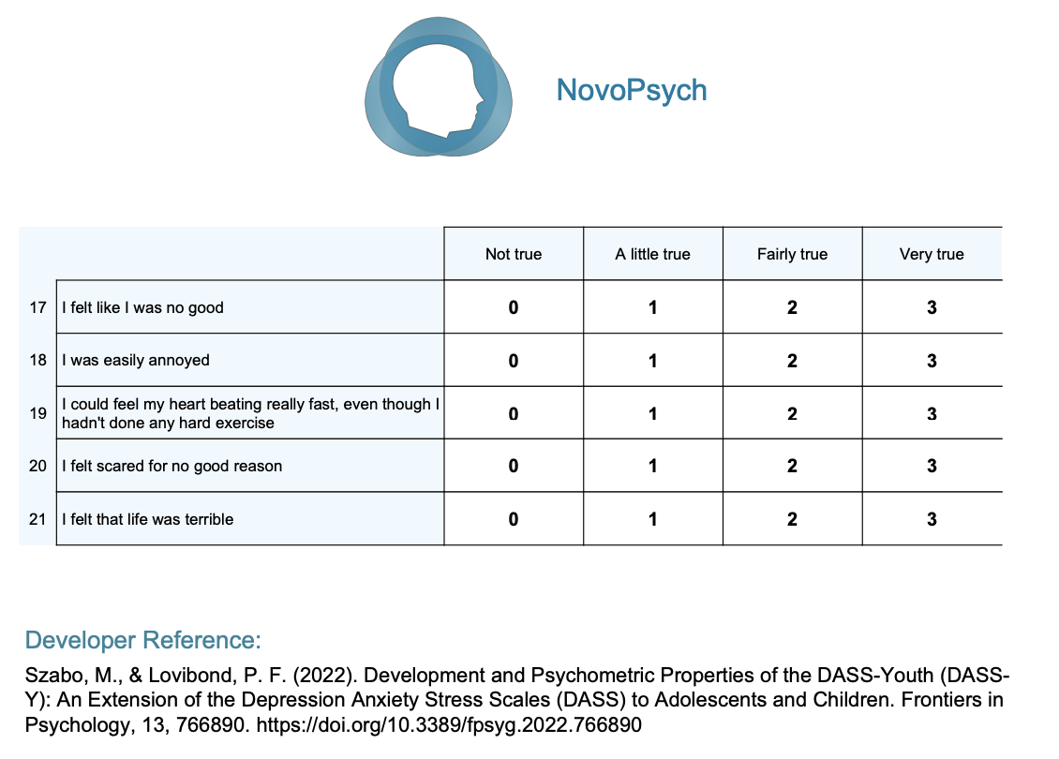

### STAI State-Trait Anxiety Inventory

**INSTRUCTIONS:** A number of statements which people have used to describe themselves are given below. Read each statement and then circle an answer sheet to indicate how you **generally** feel. There are no right or wrong answers. Do not spend too much time on any one statement, but give the answer which seems to describe how you generally feel.

|  |  |  |  |
| --- | --- | --- | --- |
| 1 | 2 | 3 | 4 |
| Almost Never | Sometimes | Often | Almost Always |

|  |  |
| --- | --- |
| _____1. | I feel pleasant |
| _____2. | I feel nervous and restless |
| _____3. | I feel satisfied with myself |
| _____4. | I wish I could be as happy as others seem to be |
| _____5. | I feel like a failure |
| _____6. | I feel rested |
| _____7. | I am "calm, cool, and collected" |
| _____8. | I feel that difficulties are piling up so that I cannot overcome them |
| _____9. | I worry too much over something that really doesn't matter |
| _____10. | I am happy |
| _____11. | I have disturbing thoughts |
| _____12. | I lack self-confidence |
| _____13. | I feel secure |
| _____14. | I make decisions easily |
| _____15. | I feel inadequate |
| _____16. | I am content |
| _____17. | Some unimportant thought runs through my mind and bothers me |
| _____18. | I take disappointments so keenly that I can't put them out of my mind |
| _____19. | I am a steady person |
| _____20. | I get in a state of tension or turmoil as I think about my recent concerns and interests |

### BIS/BAS

Behavioral Inhibition/Activation System

Each item of this questionnaire is a statement that a person may either agree with or disagree with. For each item, indicate how much you agree or disagree with what the item says. Please respond to all the items; do not leave any blank. Choose only one response to each statement. Please be as accurate and honest as you can be. Respond to each item as if it were the only item. That is, don't worry about being "consistent" in your responses. Choose from the following four response options:

|  |  |  |  |
| --- | --- | --- | --- |
| 1 | 2 | 3 | 4 |
| Very false for me | Somewhat false for me | Somewhat true for me | Very true for me |

1. A person’s family is the most important thing in life.
2. Even if something bad is about to happen to me, I rarely experience fear or nervousness.
3. I go out of my way to get things I want.
4. When I’m doing well at something, I love to keep at it.
5. I’m always willing to try something new if I think it will be fun.
6. How I dress is important to me.
7. When I get something I want, I feel excited and energized.
8. Criticism or scolding hurts me quite a bit.
9. When I want something, I usually go all-out to get it.
10. I will often do things for no other reason than that they might be fun.
11. It’s hard for me to find the time to do things such as get a haircut.
12. If I see a chance to get something I want, I move on it right away.
13. I feel pretty worried or upset when I think or know somebody is angry with me.
14. When I see an opportunity for something I like, I get excited right away.
15. I often act on the spur of the moment.
16. If I think something unpleasant is going to happen, I usually get pretty “worked up.”
17. I often wonder why people act the way they do.
18. When good things happen to me, it affects me strongly.
19. I feel worried when I think I have done poorly at something important.
20. I crave excitement and new sensations.
21. When I go after something, I use a “no holds barred” approach.
22. I have very few fears compared to my friends.
23. It would excite me to win a contest.
24. I worry about making mistakes.

### Pittsburgh Sleep Quality Index

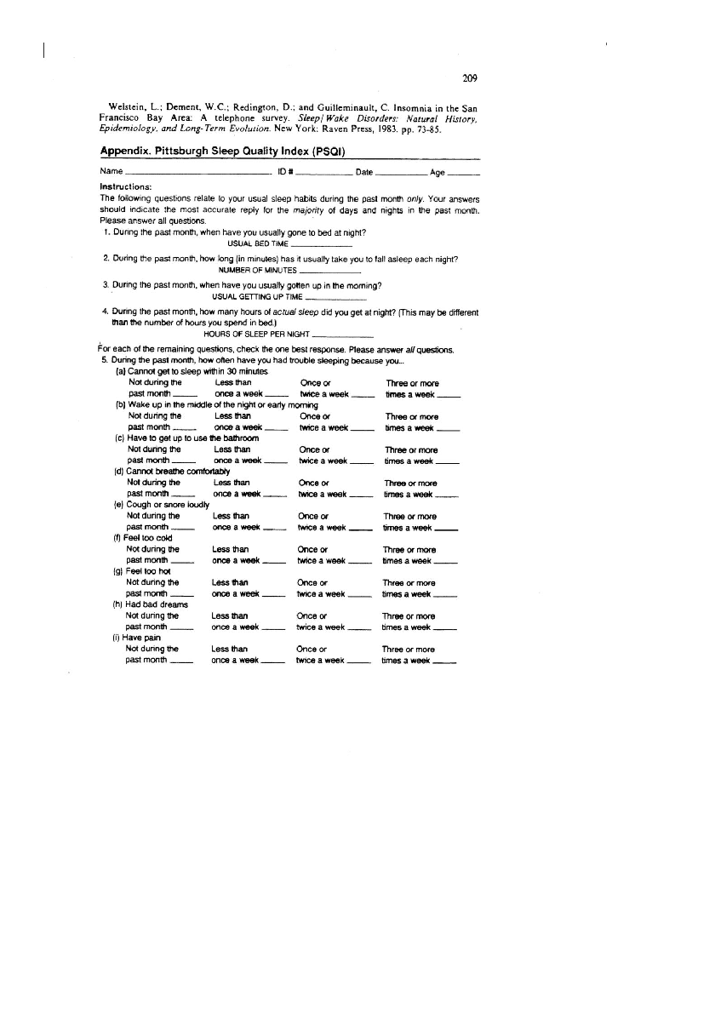

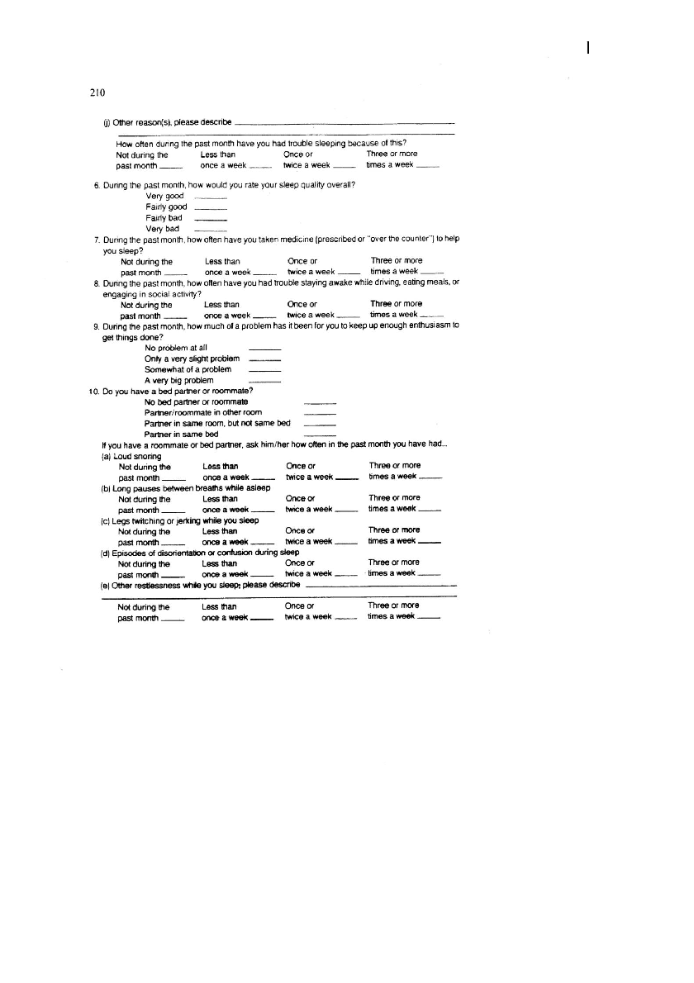

### UCLA LONELINESS SCALE

Reference: Russell, D , Peplau, L. A.. & Ferguson, M. L. (1978). Developing a measure of loneliness. Journal of Personality Assessment, 42, 290-294.

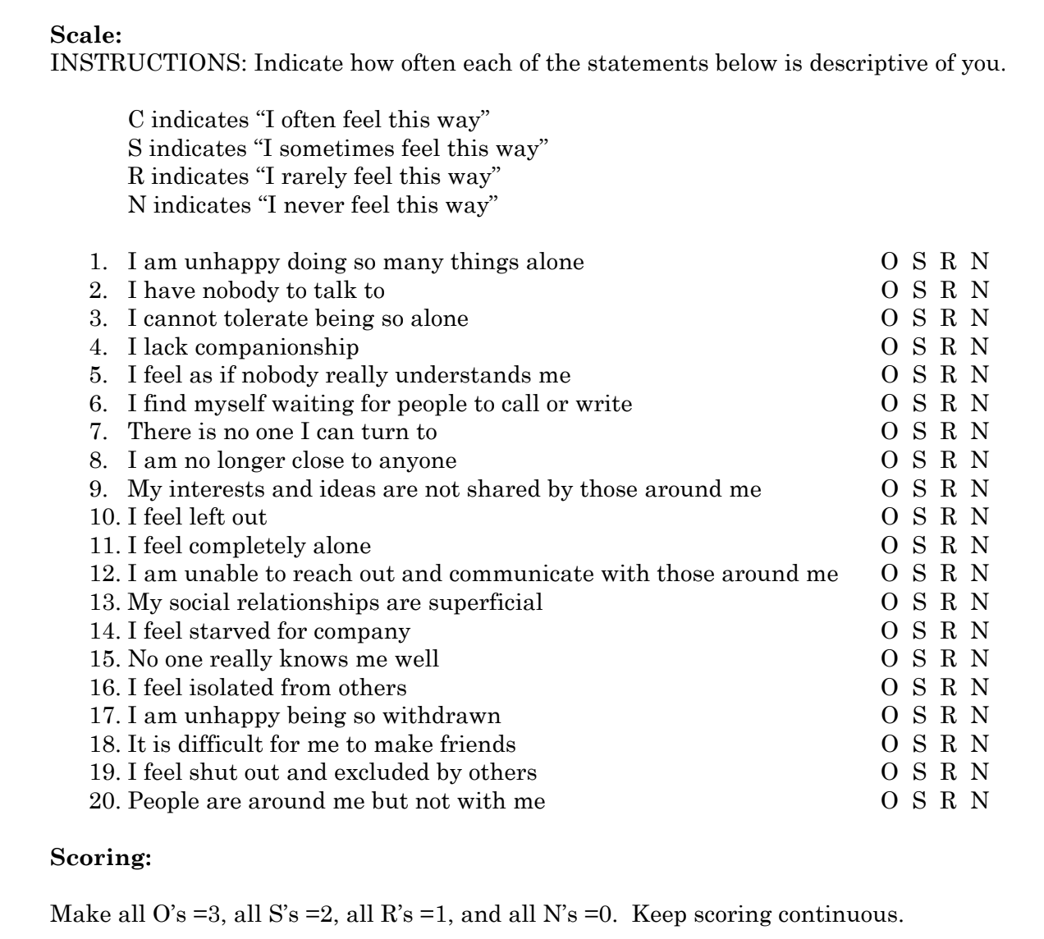

### Boredom Proneness Scale - Short Form

Option to select from 1 (Strongly disagree) to 5 (Strongly agree)

1 I often find myself at “loose ends,” not knowing what to do.

2 I find it hard to entertain myself.

3 Many things I have to do are repetitive and monotonous.

4 It takes more stimulation to get me going than most people.

5 I don’t feel motivated by most things that I do.

6 In most situations, it is hard for me to find something to do or see to keep me interested.

7 Much of the time, I just sit around doing nothing.

8 Unless I am doing something exciting, even dangerous, I feel half-dead and dull.

### Emotion Beliefs Questionnaire (EBQ)

Becerra, Preece, & Gross

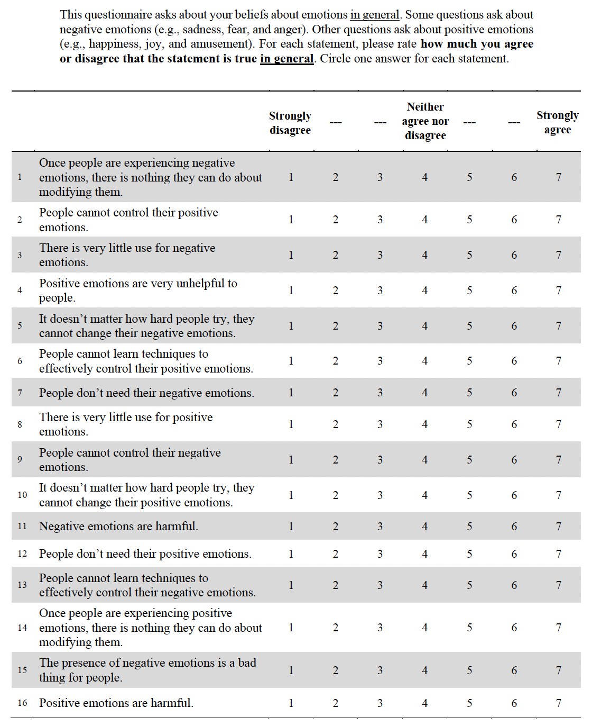

### EMOTION REGULATION QUESTIONNAIRE (ERQ)

Reference: Gross, J.J., & John, O.P. (2003). Individual differences in two emotion regulation processes: Implications for affect, relationships, and well-being. Journal of Personality and Social Psychology, 85, 348-362.

Scale 1-7, 1=strongly disagree, 4=neutral, 7=strongly agree

1. ____ When I want to feel more positive emotion (such as joy or amusement), I change what I’m thinking about.

2. ____ I keep my emotions to myself.

3. ____ When I want to feel less negative emotion (such as sadness or anger), I change what I’m thinking about.

4. ____When I am feeling positive emotions, I am careful not to express them.

5. ____When I’m faced with a stressful situation, I make myself think about it in a way that helps me stay calm.

6. ____ I control my emotions by not expressing them.

7. ____When I want to feel more positive emotion, I change the way I’m thinking about the situation.

8. ____ I control my emotions by changing the way I think about the situation I’m in.

9. ____When I am feeling negative emotions, I make sure not to express them.

10. ____When I want to feel less negative emotion, I change the way I’m thinking about the situation.

Scoring: Items 1, 3, 5, 7, 8, 10 make up the Cognitive Reappraisal facet. Items 2, 4, 6, 9 make up the Expressive Suppression facet.

### 

### Adaptive Function of Music Listening Scale

*Rate each item on a 5-point Likert-scale ranging from 1 (Strongly Disagree) to 5 (Strongly Agree)*

### Motivation for Physical Activity and Exercise

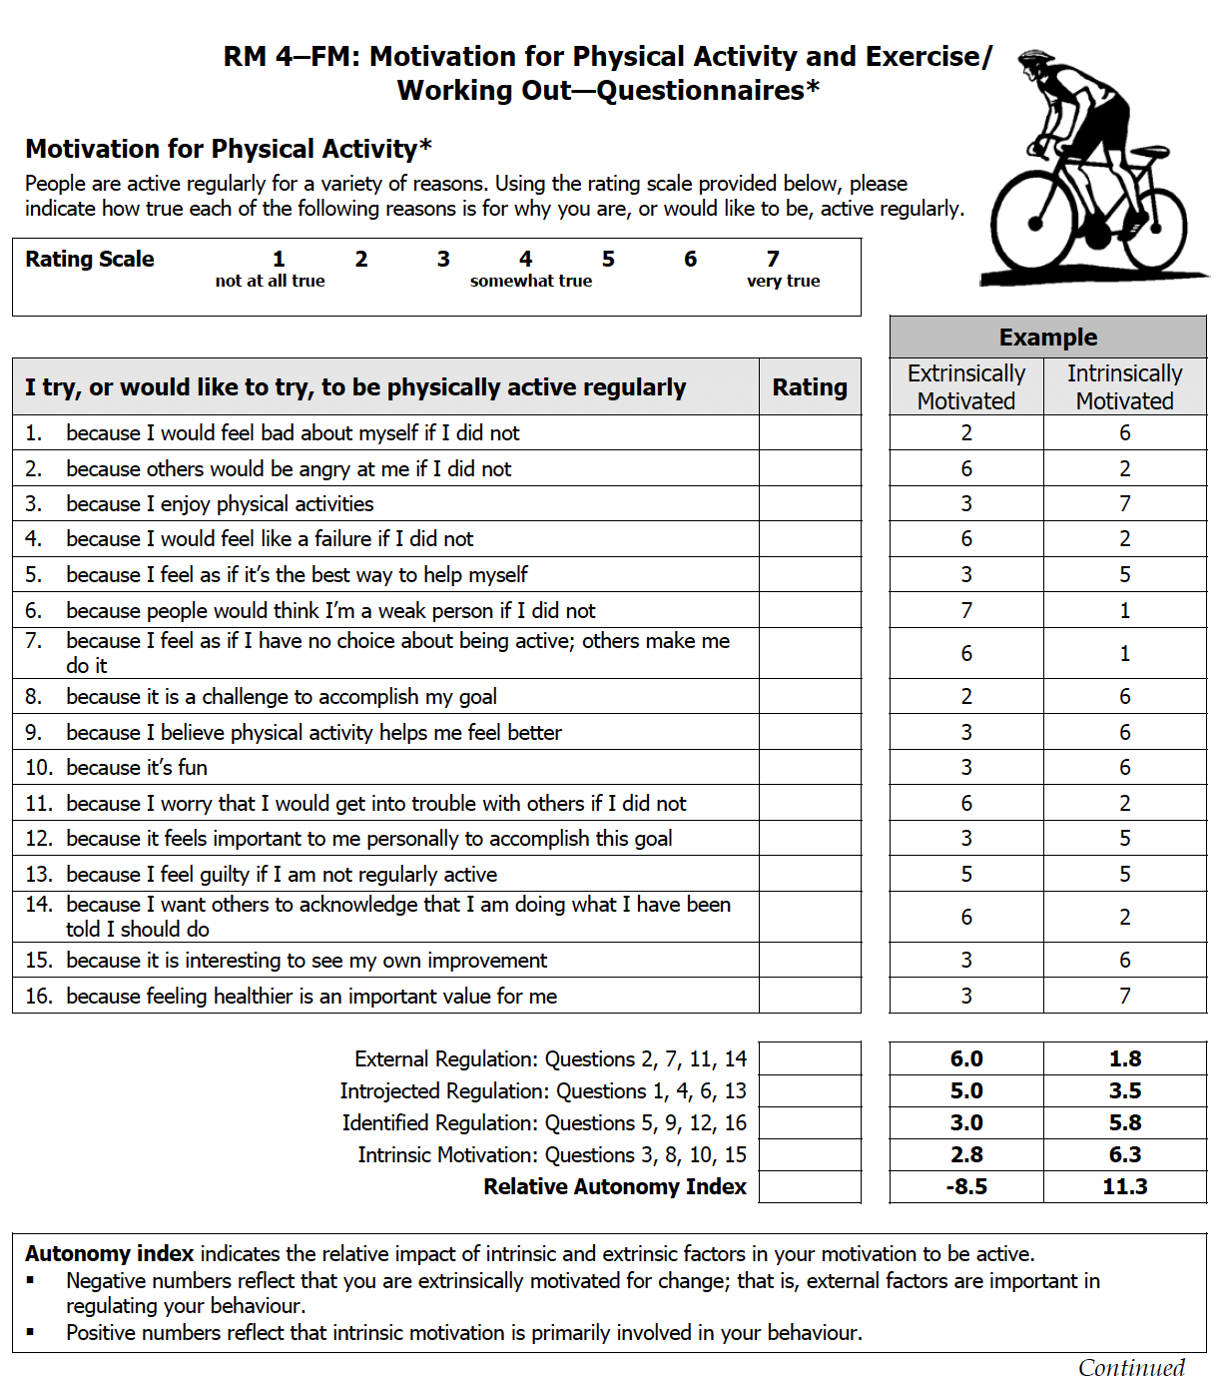

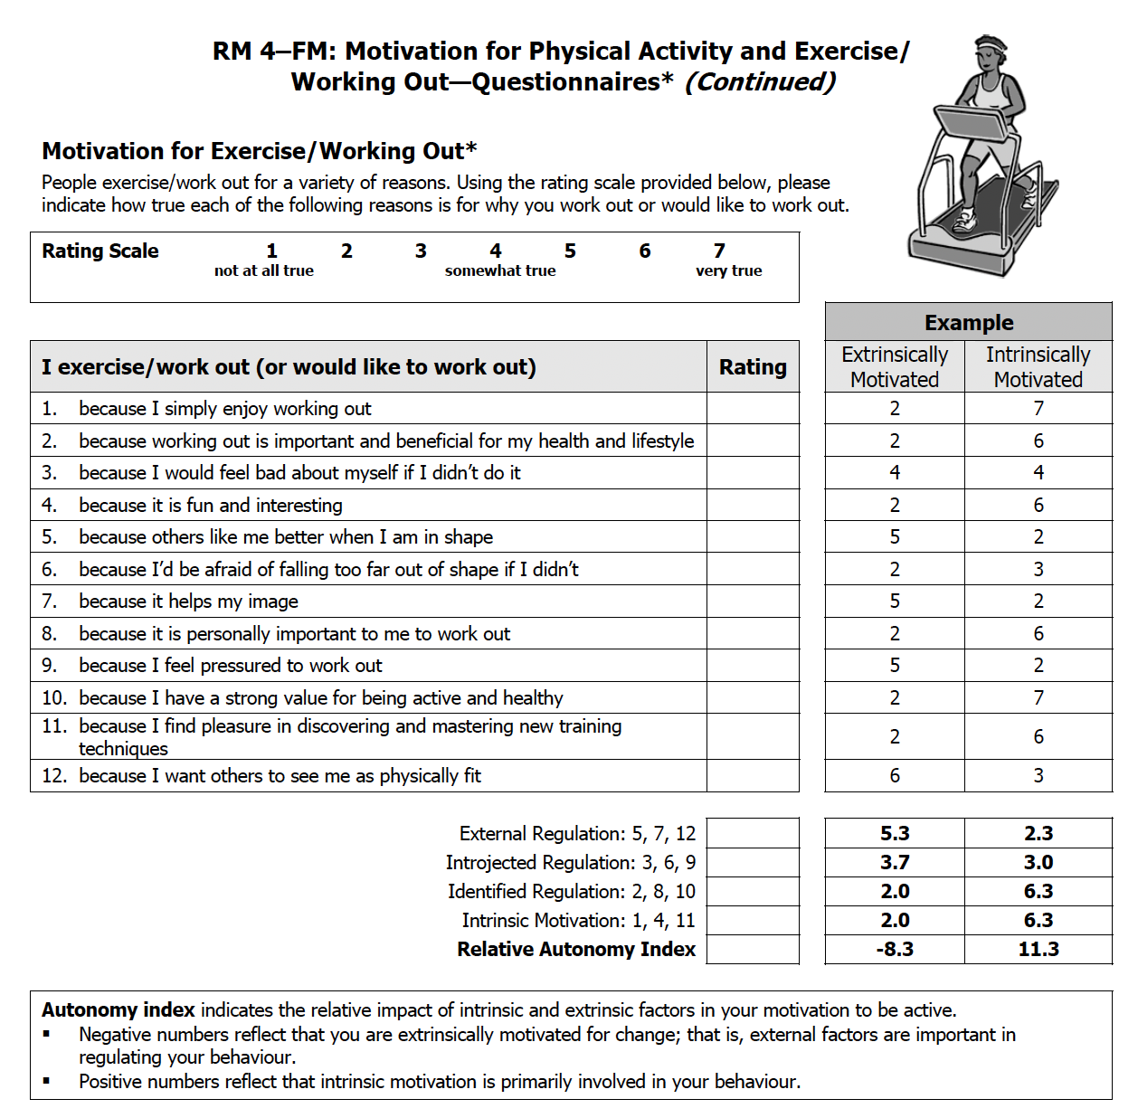

### The Eating Motivation Survey – Brief (Renner et al., 2012)

*Revised to include only some dimensions. Missing: convenience, traditional eating, sociability, price, visual appeal, social norms, social image

*I eat what I eat…*

[Liking]

Because I have an appetite for it

Because it tastes good

Because I like it

[Habits]

Because I am accustomed to eating it

Because I usually eat it

Because I am familiar with it

[Need & Hunger]

Because I need energy

Because it is filling

Because I’m hungry

[Health]

To maintain a balanced diet

Because it is healthy

Because it keeps me in shape

[Pleasure]

Because I enjoy it

In order to indulge myself

In order to reward myself

[Natural Concerns]

Because it is natural

Because it contains no harmful substances

Because it is organic

[Weight Control]

Because it is low in calories

Because I watch my weight

Because it is low in fat

[Affect Regulation]

Because I am sad

Because I am frustrated

Because I feel lonely

(1) Never (2) (3) (4) (5) (6) (7) Always